

1319 Duncan Ave

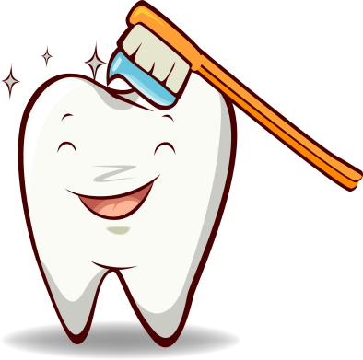 Jeffersonville, Indiana 47130

812-285-5980

In Need Of Dental Work?

We are here for you. Our Dental Program is income based for those who do not have dental insurance, so each procedure is a fraction of what a private practice charges.

We serve the Counties of Harrison, Clark, Floyd, and more…

Procedures Performed Include:

1. Exam and X-Rays
2. Cleanings
3. Simple Extractions
4. Fillings

Documents needed along with Dental Application:

1. Recent taxes for household
2. Last 30 days of check stubs for household
3. 1 Piece of Mail delivered at current address